

REVIEW OF THE YEAR 2017

St. Margaret’s Church has continued to provide a wide variety of public worship and opportunities for spiritual development for both new and established Christians throughout 2017. It is blessed by the strong commitment of many talented Ordained and Lay persons who work tirelessly as a team to promote the interests and work of God’s Kingdom throughout the Parish.

Our Incumbent, Peter Chantry, whom we share in plurality with our sister Parish of All Saint’s, Madeley, leads the Ministerial team and we continue to give thanks to God for the leadership and support that Peter brings to our Christian development.

**Work of the PCC.**

St. Margaret’s PCC has responsibility for co-operating with the Incumbent to promote the Ministry and Mission of the Christian Church, including Pastoral, Evangelical. Ecumenical and Social activities within the Ecclesiastical Parish. It also has responsibility for St. Margaret’s Church and the Reading Room.

The PCC has met on 6 occasions in the year to February 2018 for full formal meetings with an average attendance of 79%. All meetings have been structured and focused on the PCC’s responsibilities for Mission and Ministry activities, together with finance, buildings, fabric, health and safety and safeguarding and resources. Approved Minutes of all the meetings have been displayed in Church.

Priorities during the past year have been: -

* The review and updating of the Mission Action Plan (MAP) and monitoring progress on agreed activities.
* Reviewing special services
* Updating protection of young and vulnerable people policies
* Updating the Health & Safety policy
* Actioning Fellowship activities
* Fund raising activities to enable the restoration of the Church Tower stonework, clock and access to the Tower roof.

A total of 8 fund raising events were successfully held in the period February to November 2017 that had the additional benefit of being both enjoyable to those who attended and provided excellent outreach in the community. The proceeds from these events, plus generous donations from a large number of individuals and organizations, Grants from the Betley Bonfire Committee, Historic Churches Trust, the Borough Council and Betley Charities enabled the full cost of the restoration of £47,402, before VAT, to be covered. The work was completed at the end of October 2017. The VAT on the project is fully recoverable.

The project to extend the burial area in the Church Cemetery was completed in the Spring of 2017, the cost of which was fully covered by a Grant from the Parish Council and a generous donation from the Reading Room Committee.

In summary the other activities overseen by the PCC and various sub-groups during 2017 have been: -

**Mission**

* The Early Birds Sunday School has continued to be well supported and led by a team of dedicated Leaders. Their activities have been presented at the end of Holy Communion services and greatly appreciated by the congregation.
* A further Alpha course (14th) commenced in January 2018 and is the 5th held jointly with All Saint’s, Madeley.
* The PCC supported and promoted 4 Charitable Giving Sundays, The Frontier Youth Trust, Christian Aid, Sanctus (a Charity supporting refugees in Shelton, Stoke-on-Trent) and The Church of England Children’s Society. Fellowship Groups each adopted one of the charities to provide additional support.
* Gifts were donated for underprivileged children as part of “Operation Christmas Child” in collaboration with All Saint’s, Madeley.
* Collection of food for distribution at the local Food Bank continues. A total of 1285kg in 2017 was donated. (1362kg in 2016).
* A close working relationship, providing support and collaboration was maintained with Betley School. Fortnightly assembly Services were held in Church together with additional special Services to mark major Festivals. The school choir occasionally sang at Family Services and the school children helped decorate the Church Christmas Tree as well as making the Christingles and preparing flowers for distribution on Mother’s Day.
* The Reading Room continued to provide an active Christian presence in the Village and is a valuable support facility between the Church and wider community. The PCC is very appreciative of the efforts of the Management Committee and the many volunteers and helpers for their hard work and commitment.

**Ministry**

* A very well received and supported Crib Service was help on Christmas Eve in a ‘Stable’ at Betley Court Farm courtesy of Mr. & Mrs. Frank Speed. It is hoped this will become an annual event.
* A Special Service was held in September celebrating marriage. An invitation was extended to all couples recently married at St. Margaret’s.
* A Wedding Preparation Course was held jointly with All Saint’s for couples being married in 2017.
* St. Margaret’s Lunches have continued to be held on a monthly basis in the Reading Room to provide friendship and fellowship between ‘senior’ parishioners. Grateful thanks are given to all those involved in providing the lunches.
* A Men’s Breakfast was held in September with the guest speaker being Rev. Leo Varquez, Chaplain at the Royal Stoke Hospital. A Ladies Afternoon Tea took place in October with the guest speaker Fiona Ford.
* The PCC held an Away Evening with the Ministry Team to exchange ideas for inclusion in the 2018 Mission Action Plan.
* The PCC continued to support Jean Ainsworth, Linda Hough and Jim Cartlidge on their respective “Pathways to Ministry” courses and they have all participated in leading Services and have preached as part of their experience leading to Lay Ministry.
* A Confirmation Service with 12 candidates from St. Margaret’s and All Saint’s was held on Easter Sunday evening.
* There were 2 (5) Marriages, 6 (14) Baptisms and 7 (10) Funeral services in 2017. Figures in brackets for 2016. The marked reduction in these services had a significant impact on Church income in 2017 as highlighted in the Financial Report.
* The schedule of regular Services has continued as per the previous year.
* The average Sunday Service attendance, excluding those Services, which had a Baptism, remained at the same level of 66 as for the previous year, but reduced from 78 to 67 when they are included. This is as a result of the reduced number of Baptisms. Very high attendances of 100+ (including children) were recorded at Easter, Patronal Festival, Memorial Services, Harvest, Remembrance, Crib Service, Carol Service and the Confirmation at Easter.
* The three very well established Fellowship Groups continued to meet regularly to explore and share their Christian faith and all Groups met together in July and December.

**Other Administrative Issues.**

Additional comments to many of the items contained in this Report are to be found in individual reports which follow.

An application to the Heritage Lottery Fund to support the restoration of the stonework on the window and wall at the East end of the chancel was unsuccessful but following investigation by our Treasurer, it was suggested that the application be re-submitted. A reply is expected in April. 2018. This is the last of the priority items identified in the Quinquennial Report.

The PCC is very grateful to all of those people who provided financial support and involvement in the activities to raise the funds for the Tower restoration in such a short period. Thanks go in particular to the Working Group that co-ordinated the appeal and the unstinting endeavours of Margaret Moxon and Jennifer Walton and the efforts of our Treasurer, Mike Smith, in obtaining Grants.

**Electoral Roll.**

The Electoral Roll was revised in March 2017 and there were 143 people on the Roll at the end of 2017.

**Priorities for 2018.**

* Developing the Action Plan for the Parish Vision to celebrate Christ’s love, grow in Christ’s love, share Christ’s love and welcome and encourage others in following Jesus Christ.
* Subject to available finance, progress the restoration of the East window and wall stonework.
* Closely monitor finances to identify whether any fund raising events will be required to meet any deficit in the revenue account (General Fund).

**Appointment.**

The PCC looks forward to welcoming John and Laura Pallister and their baby Matilda. John has been appointed as the new Curate for St. Margaret’s and All Saint’s and will start work with us in the summer following his Ordination as Deacon on 1st July 2018. This appointment will not affect our Parish Share payment to the Diocese.

***Denzil Spencer, Lay Chairman***

2017 FINANCIAL REVIEW

The accompanying Financial Statements illustrate the movement in each of the PCC Funds in respect of the year ended 31st December 2017. The opening and closing balances of each Fund are shown on the Statement of Assets and Liabilities. End of year funds totalled £76,113.45 compared with £78,100.86 the previous year. The following additional notes are of particular relevance ***(figures in £ only):***

**TOTAL INCOME**

* **Planned Giving** at £36,682 was **£696 up** on the previous year.
* **General Collections** at £3,202 were **£70 up** on the previous year.
* **Collections at Baptisms, Funerals and Weddings** at £70 were **£814 down** on the previous year.
* **Gift Aid Tax Recovered** for General Fund at £9,800 was **£607 up** on the previous year.
* **Net income from fees** (weddings, funerals etc) at £3,304 was **£2,166** **down** on the previous year.
* **Legacies –** ALegacy of £5,000 was received during the year and was allocated to the Special Projects Fund.
* **Donations and Grants** received during the year fully covered all expenditure on the churchyard extension and the tower and clock refurbishment.

**General Fund**

Expenses were again controlled as well as possible during the year.

* **Church Running Expenses** at £3,702 were **£10 down** on the previous year..
* **Utility Bills (oil and electricity)** at £2,456 were **£512 up** on the previous year.
* **Church Maintenance Costs** at £1,271 were **£1,797 down** on the previous year.
* **Sundry Expenditure Costs** at £1,308 were **£173 up** on the previous year.
* **Local Mission & Outreach Costs** at £688 were **£151 up** on the previous year.
* **Parish Share payments** of £35,923 (2016 £35,306) were made during the year. The Parish Share was paid fully to date at the end of 2017 and obligations for 2018 amount to £36,623.
* The General Fund showed **a revenue deficit of £118 for the year** so it was not possible to make a transfer to Special Projects Fund in accordance with the PCC’s Reserves Policy (£2016 - £3,500).

**Churchyard Maintenance Fund**

* The usable area of the new churchyard was extended during the year at a cost of £3,978. This was fully funded by a donation of £2,228 from the Reading Room Fund and a grant of £1,750 from the Parish Council.
* Following the extension of the maintained area, total costs of upkeep and maintenance of the churchyard amounted to £4,420 (2016 £3,930). Grants of £2,239 were received by the fund (2016 £1,949). PCC resolved during the year that any annual surplus on Magazine Fund should be directed to the Churchyard Maintenance Fund and a transfer of £1,400 was made at the financial year end. This enabled the fund to effectively break even during the year and carry forward a small balance of £123.

**Church Fabric Fund**

* A major project to refurbish the tower was completed during the year at a total cost of £47,403 excluding VAT. As a result of a hugely successful fund raising campaign and grant applications, the full cost was raised without the need to draw on funds from PCC reserves. A balance of £5,610 was able to be carried forward (2016 - £7,141) and this will increase to £9,121 when the remaining VAT refund of £3,511 is received from the LPOW Grant Scheme in January 2018.

**Special Projects Fund**

* There was expenditure of £780 from this fund in 2017 in respect of the purchase of a replacement photocopier. A legacy of £5,000 was received during the year. PCC resolved during the year that surpluses on Magazine Fund should henceforward be directed to the Churchyard Maintenance Fund so no transfer was made to Special Projects Fund this year (2016 £1,000). There was no transfer possible from General Fund in accordance with our Reserves Policy (2016 - £3,500). A balance of £36,699 was carried forward (2016 £32,413).

**Magazine Fund**

* The Magazine Fund generated a surplus of income over production costs enabling a transfer of £1,400 to be made to the Churchyard Maintenance Fund (2016 £1,000 to Special Projects Fund) in accordance with PCC Reserves Policy.

**Reading Room Fund**

* This Fund received room hire income of £527 from General Fund during the year (2016 £562).A donation of £2,228 to the Churchyard Maintenance Fund enabled the churchyard extension to be completed without resort to other PCC funds. Donations totalling £2,300 to the Church Fabric Fund contributed to the refurbishment of the tower clock. The Reading Room Fund carried forward a balance of £13,588 (2016 £17,924).

**Reserves Policy**

Throughout the year the PCC has been fully aware of its financial obligations and regular reports have been received from its Treasurer. It is PCC policy to invest its reserve funds with the CBF Church of England Deposit Fund or other UK financial institution approved by PCC. In accordance with prudent accounting guidelines its Reserves Policy was fully reviewed by PCC in 2017. It was resolved to transfer any Magazine Fund surpluses to Churchyard Maintenance Fund from 2017 onwards. The end of year financial position was in line with the current Reserves Policy, a copy of which can be obtained by e-mail request from [mike.rsmith@btinternet.com](mailto:mike.rsmith@btinternet.com).

**Ongoing Financial Position**

**Capital Funds**

2017 was financially intensely challenging with the major tower refurbishment works completed and fully funded by donations and grants without the need to draw down from existing PCC funds. The two capital funds were able to carry forward balances similar to the previous year which was a most encouraging result reflecting a tremendous effort on the part of many.

.

**Revenue Funds**

It was disappointing to note that, notwithstanding the encouraging results from the stewardship campaign in 2016, the General Fund barely broke even during 2017 so no transfer of surplus to capital funds was possible. Analysis of the underlying figures suggests that a much lower contribution from net fees detracted from an otherwise fairly reasonable year. A formal budget for General Fund has been prepared for 2018 and will be monitored closely throughout the year. The Treasurer will continue to monitor all income and expenditure trends on a monthly and cumulative basis. He will report regularly to PCC. The PCC expects to meet its financial obligations in 2017 and beyond although the financial challenges being faced are well acknowledged.

**Mike Smith, Treasurer**

ELECTORAL ROLL 2018

At the end of March, 2017 there were 143 people on the Electoral Roll.

Before this APCM and in accordance with the Church Representation Rules, St Margaret’s revised the church Electoral Roll.

There are now 146 members on the Electoral Roll

**Margaret Moxon pp Terry Goldstraw, Electoral Roll Officer**

WARDENS’ FABRIC, GOODS AND ORNAMENTS REPORT 2017-18

**INTERNAL**

There have been no structural alterations to the Church, or any significant

repairs or decoration. However the Vestry steps had to be re-carpeted to reduce the

trip hazard.

**EXTERNAL**

Routine inspection of the headstones in both graveyards is now due. This will

be done in the Spring. Any unstable stones will be laid down.

Members of the congregation have again carried out remedial/cosmetic work

to the Church Path. Graveyard maintenance is contracted out and the

graveyards are in good condition.cc

A new area of consecrated ground has been prepared and landscaped ready for

use (Spring 2017).

The railings round the old Churchyard are in a poor state.

**GENERAL**

The Tower – essential safety work was carried out in the previous spring to

remove lose stone and a full restoration of the Tower stonework and the

adjacent window was carried out in September/October 17. This was financed

by a well supported fund-raising project.

Church Clock - during the restoration work the face of the church clock was

removed and refurbished and a new mechanism fitted

The East Window – the external tracery has eroded further since the

Quinquennial Inspection of 4 years ago and now requires urgent attention.

There are a number of outstanding items of external stonework and it is hoped

to do all this work in the next 12 months if funding can be secured.

March brought severe weather, causing a burst pipe, there was no damage to

the fabric. At the same time the boiler developed a fault, at the time pf writing

we are waiting for a spare part.

Full Health and Safety, and Safeguarding procedural reviews were carried out.

**To the best of our knowledge all other items and goods remain the same.**

It should be noted that the communion silverware has become dented and distorted

through use and needs some restoration work at some point.

**Jennifer Walton & Jim Cartlidge. Church Wardens**

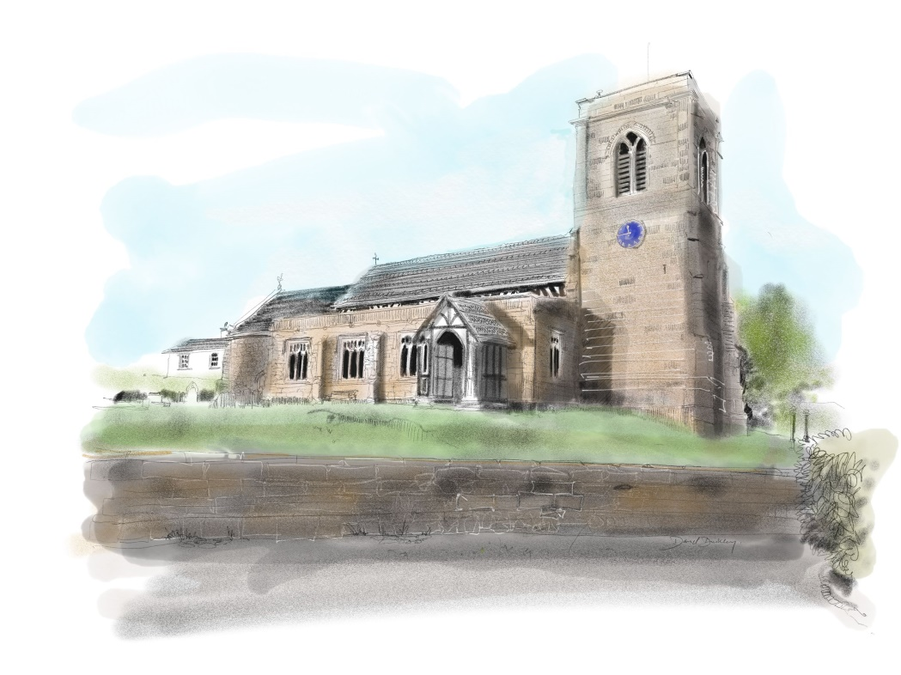

CHURCH ACTIVITIES

During 2017 Bishop Michael invited church people to focus afresh on what following Christ means in our individual lives and in the life of our Christian community.

St Margaret’s response has been the

**Parish Vision** **for 2018.**

The annual reports of Church Activities in the following pages demonstrate the Parish Vision in action.

**Celebrating Christ’s love in worship and outreach**

Living Streams

Church Music

The Bellringers

Betley Parish News

The Reading Room

**Growing Christ’s love individually and together**

Earlybirds

Praise and Play

Betley School

Fellowship Groups

**Sharing Christ’s love within and beyond our community**

The Foodbank

Charitable Giving

Deanery Synod

St Margaret’s Lunches

Marriage Support

**Welcoming and encouraging others in following Jesus Christ**

Alpha



**Living Streams**

**John 4:13-14 (NRSV)**

**‘Everyone who drinks of this water will be thirsty again,**

**but those who drink of the water that I will give them will never be thirsty.**

**The water that I will give will become in them a spring of water gushing up to eternal life.’**

The aim of ‘Living Streams’ is to encourage and nurture Christian discipleship and to promote and facilitate Christian healing. ‘Living Streams’ services are held on the first Sunday evening of each month, except for the first Sunday in January. ***Please note***: There is one exception this year; there will be no ‘Praise’ service on the first Sunday in April as this will be our Confirmation service to be held at All Saints’, Madeley.

Praise services are held at All Saints’ Madeley. Praise with Prayer for Healing services are held at St. Margaret’s Betley and offer a quieter style of worship with opportunity for prayer for healing.

For the second year running, we have seen another slight, but encouraging increase in the number of people attending, particularly the ‘Praise’ services at Madeley. We still have at least five churches represented in most services.

As with previous years, through 2017 the services were led by our own team of worship leaders with one of our ‘leaders-in-training’ from Madeley contributing to our August ‘Praise’ service. We followed the theme of ‘Songs from the Heart’ where the appointed speaker shared a study on their own choice of psalm.

Our services through 2018 will focus on ‘Praise and Healing in the Early Church’ and its relevance to us today. We shall be inviting our regular leaders and those in training to lead a study on one of the many examples to be found in Acts and the Epistles.

A warm invitation is again extended to all these services and events. Details are in the Parish Magazine and Church notice sheets with plans to include details on the All Saints’ Facebook page. If you would like to receive information, please send an email to [livingstreams12@gmail.com](mailto:livingstreams12@gmail.com) and we will add you to our circulation list *(your details will not be shared and communications are sent out ‘Bcc’!)*

***Alan Bailey, March 2018***

CHURCH MUSIC

***Let the word of Christ dwell in you richly… as you sing psalms, hymns and spiritual songs with gratitude in your hearts to God. Colossians 3.16***



**The Choir**

Choir numbers remain similar to last year with 17 adults and 7 children on the books, but there is an urgent need for more ladies to strengthen the ‘top line’. New members in any category are of course always welcome.

We thank all those who lead our worship with their voices week in and week out, for their commitment at services and practices. It is a blessing and a joy that we can enjoy such a variety of music in worship through the year.

**Weddings and Special Services**

The choir led special music on Maundy Thursday and at Advent, as well as all the usual festivals and special occasions during the year. It also enjoyed singing at two weddings during the summer. Once again a Christmas Choir, 40 strong, led the village in a wonderful Carol Service.

A dozen choristers joined in a special Evensong for Peace at Barthomley Church in September.

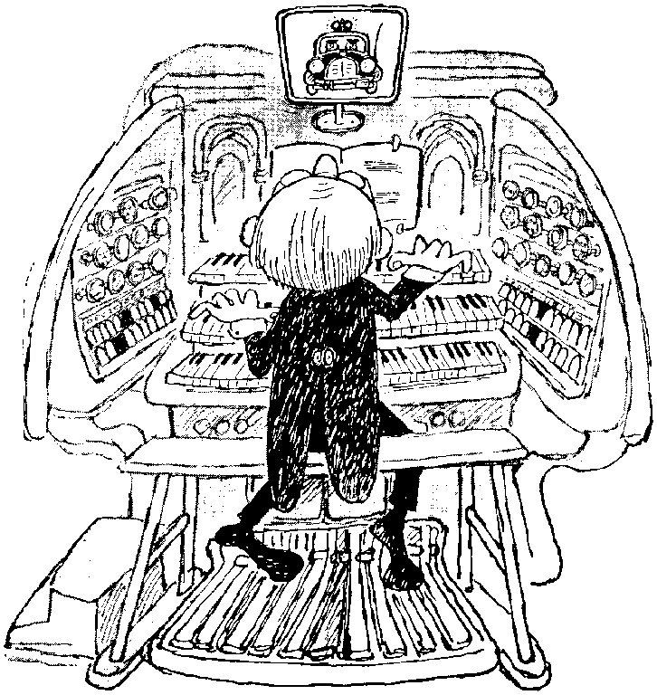**St. Margaret’s Organist**

In the last 12 months our new organist, Alison Hendricken, has become well established and has amazed us all with her progress and achievements on the organ. A combination of dedicated practice, organ lessons from Simon Russell of St. Mary’s Nantwich and a real commitment to explore the potential of this ‘new’ instrument has resulted in a contribution to our worship at St. Margaret’s that we could not have guessed a year ago.

It is good to see the congregation’s appreciation on Sunday mornings of her organ voluntaries.

We thank God for her, and we thank her for all that she is doing.

**Instruments**

Our Roland electric piano and Nicholson Organ continue to provide faultless service; in the case of the latter due to highly effective regular maintenance by J. Molyneux

***Kevin Hamer February 2018***

THE BELLRINGERS

We have 10 ringers who are all members of the North Staffs Association of Change Ringers. Whilst this seems a reasonable number for 6 bells, we sometimes struggle for ringers due to holidays and illness.

Anyone interested in learning to ring will be made most welcome and introduced to a challenging but enjoyable pastime.

In order to promote the ringing of more complex methods we are continuing to join forces on practice night once a month with Keele. This is proving beneficial to both towers.

On the 9th July we had our Tower Open Day to promote peoples understanding of bell ringing and to highlight the need to repair the stone work to the tower. The day proved to be very successful with many enthusiastic visitors, many thanks to all the ringers and friends for making everything go smoothly and to John Speed for transporting the mobile belfry. The day raised in excess of £600 for the Tower Restoration Fund.

During the work on the tower we were unable to ring, so to keep in practice we went to ring at Barthomley on their practice night, this proved to be very beneficial for all our ringers, especially our newer ringers who experienced ringing on eight bells for the first time. To repay the hospitality we received, we are trying to help them to ring for one Sunday morning service each month

I wish to thank all our ringers for their enthusiasm and commitment throughout the year.

The normal maintenance of the bells is being carried out by the ringers

***Robert Bailey 2018***

 BETLEY PARISH NEWS 

The aim of the magazine continues to be to twofold; to provide a medium for sharing information through the village, both Christian and secular, but also as a tool for outreach.

Some magazine content also gets published on the Church’s Facebook page in order to reach a wider audience. All Facebook posts are available to view from the St Margaret’s website.

Our print run is still in the order of 440 copies, most of which are hand delivered with some going out by post. A few are placed in the Reading Room and Church for casual sales, with others placed in areas where there is a “captive audience” for outreach purposes – such as Jane Hatton’s swimming pool.

The turnover of advertisers has continued this year, however, we have kept pace with filling them, without too much loss of revenue. As of the time of writing, we have three advertisers waiting for space.

Our biggest change this year has been an increase in the cover price to 60p per issue, with all the profits from the magazine going towards the maintenance of St Margaret’s graveyards.

Many thanks as always to Kevin Hamer, Sue Cheetham and her delivery team and the Print Room at Keele.

***Jim & Andrea Cartlidge***





EARLYBIRDS 



### Earlybirds is run by a team of dedicated Christian Leaders, and meets in the Vestry, during services, for fun and games.

### We deliver lessons based on the Church Lectionary (Year A 2017) on the 2nd and 4th Sunday of each month.

### The team continues to try and vary the activities to accommodate the age range of our Earlybirds on the day

Attendance is steady with numbers fluctuating from 2 or 3 children right up to 10+!

New faces are always welcome and whilst we are fairly restricted space-wise in the Vestry, we can often be seen sneaking out of the door of church to explore further afield.

Earlybird leaders aim this year is once again to continue to grow and flourish, to welcome new faces and to build upon our fellowship/friendship as Leaders of this lovely, happy group of young people.

### 

PRAISE AND PLAY 2017-18

**

*All Saints’ Madeley and St Margaret’s Betley*

*“Praise and Play”* celebrated its fourth birthday on January 26th 2018.

**Praise and Play is a simple service for Mums and Tots** (sometimes dads or grandmas). We run weekly during term time and this year we have welcomed over 75 families – *thankfully not all at once!*

**The sessions are full of fun and friendship: crafts, songs, drinks and biscuits and lots of chat.** We praise and thank God together. There is a strong team of volunteers (jointly from St Margaret’s and All Saints’) who support the mums and love playing with the children.

**Praise and Play is more than a baby and toddler group – it an introduction to worship and a meeting place for friendship, prayer and support.**

For many of the mums who come, it is a weekly highlight – a chance to come out into a safe place to meet friends and for the children to socialise and join in with a simple service complete with a take-home craft.

**Praise and Play is one of the best things we do through the week and a much appreciated outreach into our community – it is lovely to see the church full of life and fun**. It is also an important part of our baptism support ministry – it is great to be able to invite young mums and dads to something that is focused on their needs and a very Godly ministry.

**Praise and Play:** *a very special gathering for young parents and their children – a weekly highlight - sharing the love of God with young families*

***Peter Chantry - April 2018***

BETLEY SCHOOL REPORT



This year has been yet another great year for Betley Primary School, with the church continuing to play a part in the life of the school. Rev Peter is continuing to play his vital role within the school (His Tuesday afternoon school service continues to run on a fortnightly term time basis), and he has, through his position on the governing body, had input into the creation of the new R.E. Syllabus.

This year we have also seen some staffing changes. We said a sad farewell to Mrs Robinson-White who has moved on to pastures new, and welcomed her replacement Mrs Jennings.

We also welcomed a new Executive Deputy Head (across the federation), Mrs Whittingham, who at the

time of writing, along with Mrs Graham and Mrs Meir are all heavily pregnant. We wish them all well with their pregnancies.

Miss Stafford, is continuing to oversee the school choir, whose numbers are steadily growing, with the children attending some Sunday morning services as well as events in the Reading Room.

This year the school put on the Nativity Play “Born in a Barn” at church, and continued with its tradition of decorating the church Christmas tree (with the children’s handmade decorations)..

Please continue to pray for the work of Betley Primary School as it plays an important role in the life of the Church.

.

***Jim Cartlidge, Chair of Govern***

FELLOWSHIP GROUPS

***They devoted themselves to the apostles’ teaching, and to the fellowship,***

***to the breaking of bread and to prayer. Acts 2.42***

Our three fellowship groups have continued to meet, usually, in the Reading Room on a twice a month basis. They all enjoy fellowship, food, worship and discussion on some aspect of the faith. They are self organising but under the general oversight of St. Margaret’s Ministry Team. Total membership of these groups is 30 -35 people.

They are a great way for us all to deepen our understanding and faith, through sharing and mutual support….. and have some food and fun in the process.

Two of the groups support particular Christian charities, both in prayer and practical ways.

**Searching Issues !**

1st and 3rd Tuesdays from 10.00 – 12 00 in the Reading Room.

Enjoy homemade cake, biscuits and coffee.

Currently studying ‘***The character and calling of Moses’***

*Co-ordinator - Mike Darlington*

**Puddings !**

1st and 3rd Tuesday evenings at 19.30 in the Reading Room

Enjoy different puddings every week.

Currently exploring some of the ***Psalms – Prayers for the Heart***

Chosen Mission Link – 2017 - Frontier Youth Trust. 2018 – St. Luke’s Hospice

*Co-ordinators – Revd. Peter Chantryand Jennifer Walton*

**Just Desserts !**

1st and 3rd Wednesday evenings at 19.30 in the Reading Room

Enjoy cheese, biscuits and fruit.

Currently exploring ***The Sermon on the Mount***.

Chosen Mission Link – Sanctus, St. Mark’s Shelton

*Co-ordinator – Kevin Hamer*

There is a warm welcome for anyone interested in joining one of these groups; or even just to have a ’taste’ ! Contact the relevant co-ordinator.

**Publicity**

The existence and activities of the three Groups are kept in the ‘public eye’ through references on the weekly pew sheet and the monthly Parish Magazine.

**Joint Events**

All the groups attended a Summer Gathering at the Willescroft’s home, as well as an Advent party in the Reading Room.

***Kevin Hamer February 2018***

***For I was hungry and you gave me something to eat (Matt.25.35)***



Since August 2012 St. Margaret’s has organised collections of non-perishable food for the Newcastle-Staffs Foodbank, which supplies six distribution centres throughout the Borough. Between April and September last year **1,897 emergency 3 day food supplies** were issued. A third of these were for children.

Collection boxes exist in the Reading Room and at Church, just inside the church door to receive contributions from the whole community. Every week Betley’s contributions are taken to the warehouse at Silverdale; we are very grateful to **Gill Seymour** in helping with this.

**During 2017, the community gave 1,285 kgs of food !**

Whilst this is 6% less than the previous two years it is still a most significant and important contribution, much appreciated by all at Newcastle Foodbank – and the clients that they help.

Kerry Dunstan, Communications Volunteer for Newcastle-Staffs Foodbank has said:

*“Every week people are referred to us after something unavoidable - like illness, a delayed benefit payment or an unexpected bill - means there’s no money for food. It’s only with local people’s help that we’re able to provide vital support when it matters most, Thank you so much to everyone who already donates time, food and money.!”*

The Newcastle-Staffs Foodbank exists to help local people in crisis. Local professional people such as doctors, health visitors, social workers, Citizens Advice Bureau staff, welfare officers, the police and probation officers, identify people in need and issue them with vouchers to enable them to obtain emergency food for them and their family for up to 3 days.

At distribution centres around the Borough volunteers meet clients over a cup of tea and are able to signpost them to agencies who can help resolve any longer-term problems they may have.

People continue to struggle with benefit payment delays, low wages and insecure work and therefore the need for this service will not end anytime soon; therefore it is important that we maintain its profile in the community. To this end regular updates appear in the Parish Magazine and on the Reading Room and Church noticeboards.



*The Newcastle Foodbank is seeded by the Trussell Trust*

*but works independently through the Borough of Newcastle*.

[*www.newcastlestaffs.foodbank.org.uk*](http://www.newcastlestaffs.foodbank.org.uk)

***Kevin Hamer February 2018***

**St. Margaret’s PCC**

**SUMMARY OF CHARITABLE GIVING**

**Financial Year Ended 31 December 2017**

***(It was the policy of the PCC to focus its charitable giving for 2017 on 4 pre-determined Christian or other charitable causes in the UK and abroad, in addition to meeting its commitments to the Lichfield Diocese).***

***(Amounts rounded to the nearest £)***

**2016 2017**

***Voluntary Income* ££**

**Planned Giving 35,876 36,682**

**Tax Recovered 9,193 9,952 \***

**Other Collections and Giving**  **10,522** **5,362 \***

**TOTAL 55,591 51,996**

**(Note: * = excluding Tower Fund income)**

***Payments Made***

**Lichfield Diocese Mutual Support Fund 9,311 9,543**

**(Element of Parish Share above**

**allocated costs of ministry)**

**Grants – Relief/Development**

**Christian Aid 532 712**

**Grants – Home**

**Frontier Youth Trust 527 859**

**Children’s Society 472**  **482**

**Sanctus St Mark’s 778 1,257**

**TOTAL 11,620 12,853**

**Giving % of Voluntary Income (20.9%) (24.7%)**

**DEANERY SYNOD REPORT 2017- 2018**

Three Deanery Synod meetings were held and 3 Deanery Synod Worship services. Main meetings opened with worship led by the host parish followed by Deanery and Diocese activities (which have been reported to PCC previously during the year) and followed in each case by very informative and different presentations.

Parishes were thanked for achieving nearly 100% of Parish Share.

Presentations at meetings.

1). Revd. David Primrose gave a presentation on dementia friendly church.

By 2030 20,577 church members will have Dementia.

How does a church become dementia friendly?

Don’t change the layout often, have signs to the toilet AND BACK and other areas.

Make it spirituality important and relative to people with Dementia.

Memory Box in a church context containing items relevant to people who have been

members for years, eg. old style prayer and hymn books.

Allow people with dementia to ‘twiddle’ with things eg. twiddle muffs and pinnies.

Be aware it affects the whole family.

2a). Ms Becky Hurst from Christian Aid introduced the work of Christian Aid making the following comments:-

CA work with partner organisations throughout the world in delivering help and support.

CA provides education especially on health issues to help stop the spread of disease.

CA is there for the long term and work worldwide.

Ways as Christian’s we can support the work of Christian Aid are Prayer and include CA

as one of the church’s charities.

2b). Revd. Bill Mash of the Black Country Urban Industrial Mission spoke on ‘Mission in the world of work’. The aim of the BCUIM is to connect the church and the economy.

There are 3 themes:- *Engaging with the Economic order, Workplace chaplaincy, Faith at work.*

3). Revd. [George Fisher](x-apple-data-detectors://6) from the Hope Project gave a presentation of their aims (based on Colossians chap.4 v.2-6).

WHY?

The dream is for every church in UK to grow by 10% of new followers.

HOPE will partner you to make this a reality. HOW?   5 ways to begin.

Something to pray for - pray each day for 5 people known to you that they will come to

know Christ.

Something to say - use your own story of faith.

Something to give - take a church leaflet or magazine.

Something to invite them to a special event eg. Centenary this year WW1.

Be ready to welcome them.

Both Deanery Synod and the Worship meetings are open to everyone and are highly recommended to anyone who is keen to know about the wider activities of church life locally.

***Deanery Synod Representatives: Gill Gibson, Linda Hough, Helen Shorrock***

ST. MARGARET’S LUNCHES

In May this year St. Margaret’s Lunches will have been taking place for 2 years! These happy, relaxed gatherings have continued monthly in the Reading Room, where those living alone in the village are able to share a meal together and enjoy some company in a comfortable and friendly environment.

We currently have 40 names on our list and are able to offer invitations to around 12 people each month.

The Revd. Peter or Revd. Pamela is present on each occasion to welcome guests and join in the meal time.

We are extremely grateful to our teams of cooks and helpers who continue to provide beautiful food and a cheerful presence to take care of our visitors.

Extra names to add to our list of cooks would be greatly appreciated!

***St. Margaret’s Lunch Team February 2018***

MARRIAGE SUPPORT

**2018 currently has 10 weddings booked in at either St Margaret’s or All Saints’ Madeley.** It is a great privilege to welcome, meet with and support couples preparing for marriage.

**On Sunday 18th March, we are expecting 5 couples for our annual Marriage Sunday Lunch and Workshop.** The session is entitled: *Bins, Bogs and Brilliant in-laws* and is designed to help couples take a light-hearted yet serious look at the things that make a marriage strong and resilient and above all else loving.

This year the workshop will be led by Alan and Judith Bailey and myself. Couples who’ve come in previous years have been very quick to express their gratitude and appreciation for how the session has impacted on them.

*“We have found ourselves going over the stuff we did in the workshop and learning new things about each other. Thanks for a great session.”*

**This year we hosted a *“Celebrating Marriage”* service at St Margaret’s Betley on Sunday September 24th** at 6.30pm when many couples gathered to re-affirm their marriage vows. This was celebrated with cake and bubbly after the service.

***Peter Chantry***

** ALPHA 2018** 

The Alpha Ministry in Madeley and Betley has been a great boom to our life as a church. Many have attended; many have helped with the catering; many have spoken at the sessions; and many have faithfully prayed for all involved. And through Alpha many of us have grown in our faith and confidence in Christ.

This year the group comprises 11 participants and 2 leaders – Jim Cartlidge and Peter Chantry. We are looking forward to a Confirmation Service on Easter Sunday evening with Bishop Geoff as our Confirming Bishop.

We have had some new speakers this year in the persons of Samantha Harrison and Linda Hough – Linda spoke on prayer and Sam on God’s guidance. Both talks were very well received.

As in previous years, the group has been wonderfully supported by the prayers of the church and indeed the lovely catering – thanks to all and especially to Margaret Floyd and Hilary Laine for their co-ordination.

The class of 2018 has thoroughly enjoyed Alpha. *How about YOU joining the Alpha group next year?*  
***Peter Chantry and Jim Cartlidge***

STRUCTURE, GOVERNANCE AND MANAGEMENT

The Parochial Church council (PCC) is a corporate body established by the Church of England.

The PCC operates under the Parochial Church Council Powers Measure and is a charity exempt from registration with the Charity Commission,

The method of appointment of PCC members is set out in the Church Representation Rules.

At St Margaret’s the membership of the PCC consists of the incumbent (our vicar), an ordained local minister, churchwardens, a readers’ representative and members elected by those members of the congregation who are on the Electoral Roll.

All church attendees are encouraged to register on the Electoral Roll and stand for election to the PCC

All PCC members are elected to stand for one year. Deanery Synod representatives are elected for a period of three years and are members of the PCC on election.

There are three formally constituted groups responsible to the PCC

* **The Standing Committee**, which is empowered to take specifically delegated or urgent decisions on behalf of the PCC.
* **The Ministry Team**, who share responsibility with the incumbent for the spiritual development and mission of the Parish.
* **The Reading Room Committee**. Through a deed (the ‘Trust Deed’) made between Lichfield Diocesan Trust (‘the Trust’) and St Margaret’s PCC, the Trust ‘stands possessed of the Reading Room property’ on behalf of the PCC which is the Administrative Trustee.

In its capacity as Administrative Trustee, the PCC has appointed a Reading Room Committee to manage the Reading Room in accordance with its aims as defined in the Trust Deed.

ADMINISTRATIVE INFORMATION

St Margaret’s Church is situated in Church Lane, Betley, Crewe, CW3 9AX. It is part of the Diocese of Lichfield within the Church of England.

The Parish is held in plurality with All Saints’, Madeley, with one incumbent, the Revd Peter Chantry, BSc, BA (Hons.)

Correspondence should be addressed to the PCC Secretary, St Margaret’s Church, Church Lane, Betley, Crewe, CW3 9AX.

**PCC MEMBERS**

who have served at any time from the 23rd April 2017 until the date this report was approved are:

**EX OFFICIO MEMBERS;**

Incumbent Revd Peter Chantry (Chairman)

Ordained Local Minister Revd Alan Bailey

Reader and Warden Jennifer Walton

Warden Jim Cartlidge

**DEANERY SYNOD REPRESENTATIVES**:

Helen Shorrock

Linda Hough

Gill Gibson

**ELECTED MEMBERS:**

Audrey Darlington

Ann Deavall

Nick Deavall

Jane Hamer

Linda Hough (Publicity Officer)

Rick Hough

Margaret Moxon (Secretary)

Denzil Spencer (Vice- Chairman)

Mike Smith (Treasurer)

Bernard Swift (Church Clerk)

Annie Williams

The following have served as **DEPUTY WARDENS**  to support the Wardens in Church

Jean Ainsworth

Terry Goldstraw

Helen Shorrock

Bernard Swift